|  |
| --- |
| VENOM STUDIOS |
| Zero TRIGGER |
| **[ARCADE GAME]**    **Insert a Company Logo here** |
| Version #1.0  All work Copyright © 2012 by XX Games.  All rights reserved.  **Andre Reano 101075780**  **Anto NanahJi 101103788**  **Logan King 101100360** |
|  |
|  |

|  |
| --- |
| May 16th 2012 |

**Table of Contents**

Version History 3

Game Overview, Game Play Mechanism 4

Camera, Controls, Interface Sketch 4

Menu and Screen Descriptions, Game World 4

Level, Game Progression 5

Character, Enemies 5

Weapons, Abilities, Scoring 5

Cheat Codes, Sound Index 5

Art/Multimedia Index, Future Features 5

**[**​**ZERO TRIGGER**​**]**

**Version History**

https://github.com/antoNanahJi/Android_SideScrolling_Game

1. **Game Overview**

Zero Trigger is a side scrolling/action game. The goal is yet to be determined.

1. **Game Play Mechanics**

Action platformer with feature to jump and run through the level. Ideas: Endless Runner, Megaman oriented, Mario oriented.

1. **Camera**

*2D*

1. **Controls**

Touch input on mobile. There are different buttons on the screen to move, jump and fire.

1. **Interface Sketch**

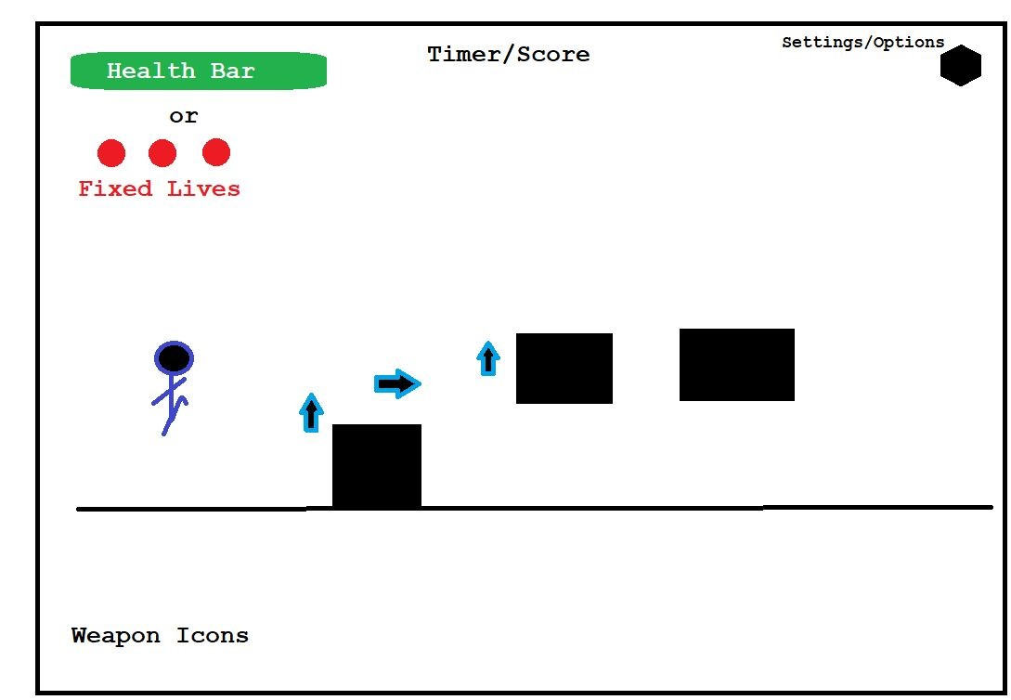

1. **Menu and Screen Descriptions**

Menu will contain simple options: music toggle, quit game.

1. **Game World**

The game world background is a tall forest of green trees. While player plays on flat plain faced with numerous obstacles.

1. **Levels**

Platform base level.

1. **Game Progression**

The player must reach and defeat the final boss.

1. **Characters**
2. Main character will have a futuristic battle suit.
3. Will be able to yield 2 weapons
4. Health bar or fixed life system
5. **Enemies**

Simple enemy walks around and causes damage to the player, an enemy chase the player and a final boss attacks the player.

1. **Weapons**
   1. Gun
   2. Sword
2. **Abilities**

Players weapon does double damaging when player pics a power up

1. **Scoring**

There are coins/diamonds to collect and increase score.

1. **Cheat Codes**

Difficulty set up option.

1. **Sound Index**

Background music, enemy kill, power up, firing, start screen……

1. **Art / Multimedia Index**

The assets that are in our game is on git hub in folder called (Gabson - Pixel_Art_Pack).

1. **Future Features**

Adding second Level.